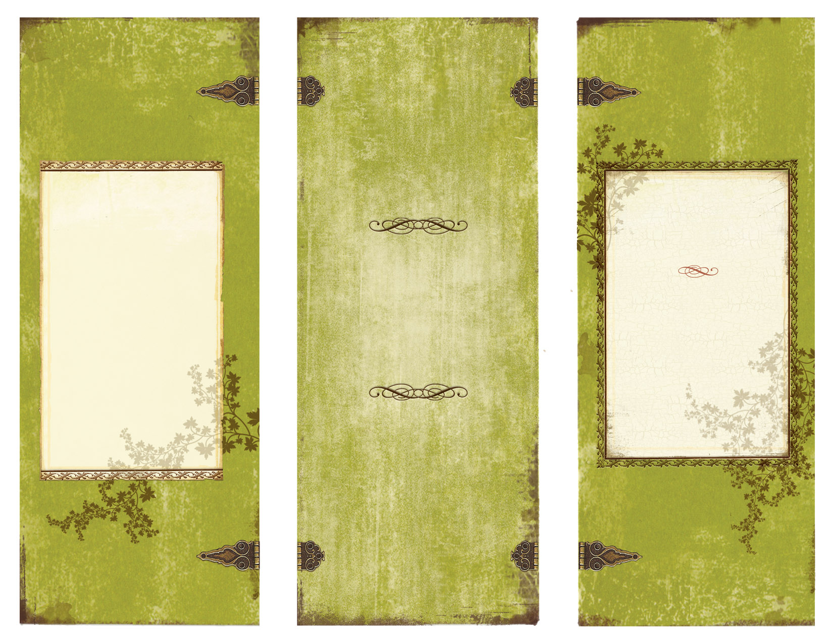

• Arthur N. Applebee. (1989). A Study of Book-Length Works Taught in High School English Programs. Report Number 1.2. Albany, NY: Center for the Learning and Teaching of Literature.

• Berila, B., Keller, J., Krone, C., Laker, J. & Mayers, O. (2005). His Story/Her Story: A Dialogue About Including Men and Masculinities in the Women's Studies Curriculum. Feminist Teacher, 16(1), 34-52.

• Gurian, M., Henley, P., Trueman, T. Boys and Girls Learn Differently: A Guide for Teachers and Parents, Jossey-Bass Books:, USA: 2001 Pages 1-40

* Dionne, Anne-Marie “ Developing Critical Literacy Skills – Exploring Masculine and Feminine Stereotypes in Children’s Literature” Research Into Practice 32 (2010) Print

• Hamilton, M., Anderson, D., Broaddus, M, & Young, K. (2006). Gender Stereotyping and Under-representation of Female Characters in 200 Popular Children’s Picture Books: A Twenty-first Century Update. Sex Roles, 55(11), p.757-765. DOI: 10.1007/s11199-006-9128-6

• Millard, Elaine. Differently Literate: Boys, Girls and the Schooling of Literacy, Falmer Press, USA: 1997 Pages.9-13

* Ontario. Dept. Ontario Ministry of Education. Me Read No Way! A Practical Guide to Boys’ Literacy. Queen’s Printer for Ontario, 2004 Print.

• Wiki on Gender Inequity Created by Jordan Smith in Fall 2010: http://languageandliteracytheoryandpractice.wikispaces.com/Gender+Inequity+in+the+English+Classroom

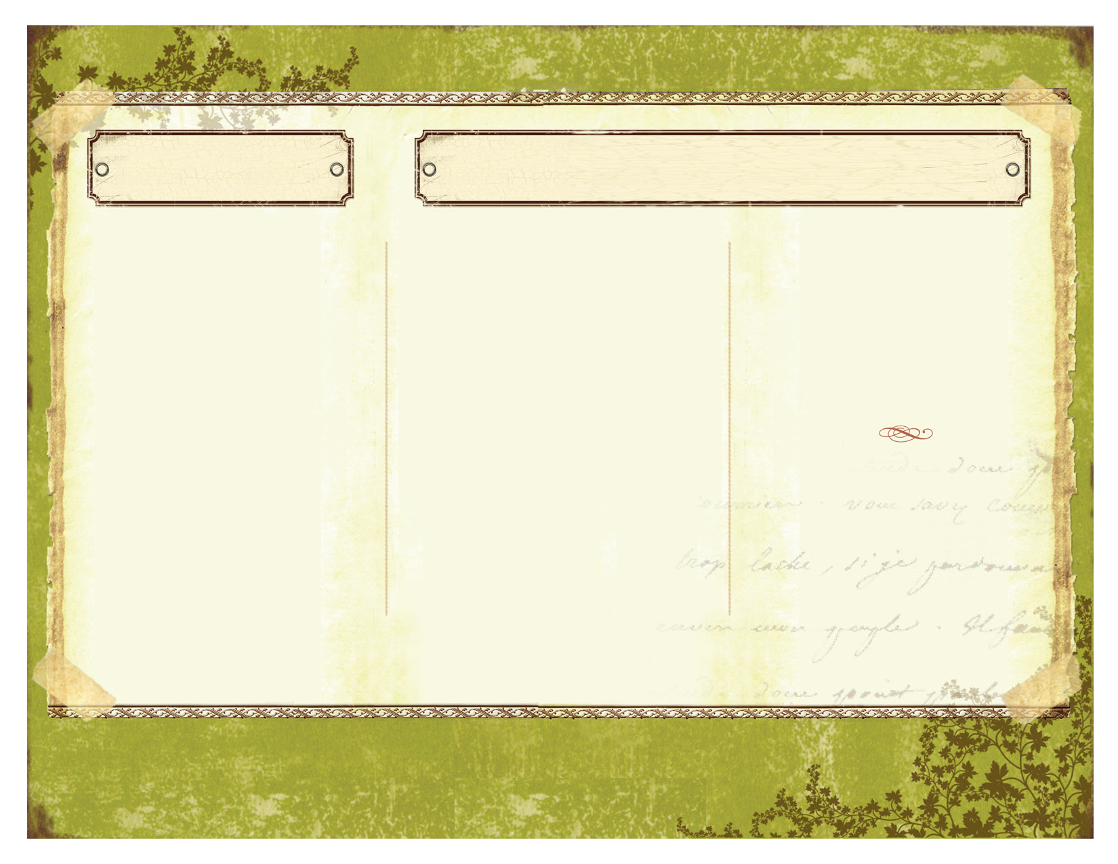

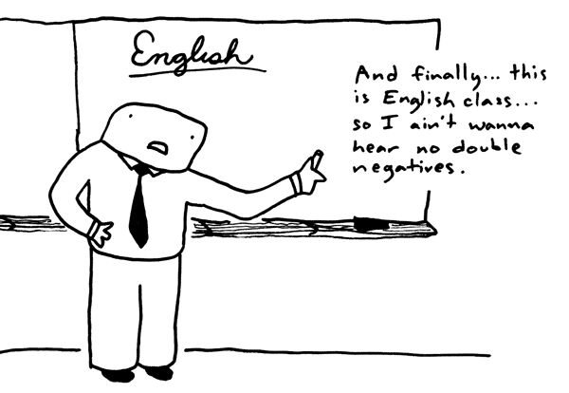

Specifically, the English Classroom

Throughout Canada

* Ontario = Grade 3 & 6 testing in math and reading showed, "...persistent and glaring discrepancies in achievements and attitudes between boys and girls." (O'Neill, 2000)
* British Columbia = standardized testing indicates that girls outperform boys at all levels of reading and writing
* Alberta = testing shows that girls, "...significantly outperform boys on reading and writing tests, while almost matching them in math and science." (O'Neill, 2000)

Gender Inequality in the Classroom:

Andre

Ian

Jordan

Wafiyyah

**Critical Literacy Classroom Activities:**

* Venn diagram to compare characteristics in traditional & cotemporary fairy tales
* Compare jobs in literature & follow-up with discussions of real life
* Compare literature aimed at different sexes & then write a journal entry on the features of both

**Key Issues:**

* Under representation of female authors
  + 5 out of 82 texts
* Gender stereotypes
  + Male characters outnumber female
  + Stereotypical roles and occupations (e.g. indoor vs. outdoor)
* ‘So, we learn differently?’
  + Neurologically vs. environment
  + Earlier onset of vocab for girls & effective communication skills at a younger age.
  + Preferences of genre
    - Girls = human dynamics vs. Boys = engagement & excitement
    - Girls prefer narrative fiction
    - Boys prefer wider variety of genres & a broader range of topics
* ‘We read differently?’
  + Read for different purposes
    - Utilitarian vs. Intrinsic Pleasure
* Communicate messages that justify social inequalities
  + Cultural values that transmit ideologies
  + Gender representations are often sexist, especially gender asymmetry in children’s literature
* We aim to conform to the stereotypes presented to us
* Teachers must….
  + Provide skills to deconstruct text
    - Identify unjust messages & justify inequitable power relationships
  + Consider the purpose of the text
  + Examine representation
  + Analyze methods
  + Consider the power of language use

here.

here.

Continue brochure text here.

Continue brochure text here. Continue brochure text here. Continue brochure text here. Continue brochure text here. Continue brochure text here. Continue brochure text here. Continue brochure text here. Continue brochure text here. Continue brochure text here. Continue brochure text here. Continue brochure text here. Continue brochure text here. Continue brochure text here. Continue brochure text here.

Continue brochure text here. Continue brochure text here.

Our Research Suggests…… Our Research Suggests……

What Can We Do?

