Hook and Hands-On Science Lesson Plan:
Identification and Classification of
Rocks and Minerals

LESSON TITLE: (CHOSEN CONCEPTS)  Identification and Comparison of rocks and Minerals | TIME REQUIRED:  2x30 min lessons  GRADE: 4  TEACHERS:  Nathan Hobson  GROUPINGS:  Whole class  STRATEGIES:  Cooperative Learning  Hands-on activity  MATERIALS/RESOURCES:  - Word Wall  - KWL chart  - T-chart: Characteristics of  Rocks and Minerals  - 8 samples of rocks and  minerals  - Mystery Box to contain  samples  - laminated Rock/Mineral Identification Worksheet Poster (for group work)  - Dry eraser and marker  ASSESSMENT:  STRATEGIES USED  - Ensure they understood the task, and are engaged in the activity.  - Look for students who may need assistance or further clarification.  Record observations made during lesson on individual Observation Notes.  - Use Observation Checklist to assess students’ oral participation, critical thinking and understanding of material during group activity.  - End of unit assessment;  Students will complete “Missing Word” Quiz (includes concepts learned in prior lesson).  SAFETY CONCERNS  PERTINENT TO ACTIVITIES CHOSEN  - Remind students about proper handling of the material to avoid injury.  - Make students aware of the brittle nature of some samples, such as Mica, which is brittle and Amethyst, which breaks into small fragments if dropped.
SUBJECT/STRAND:
Grade 4 Science and Technology
Understanding Earth and Space Systems -Rocks and Minerals
EXPECTATIONS COVERED:
Overall Expectation:
Students will:
- INVESTIGATE, test, and compare the physical properties of rocks and minerals;
- DEMONSTRATE an understanding of the physical properties of rocks and minerals.
Specific Expectation
Students will:
2.2 use a variety of tests and methods to classify rocks and minerals.

BACKGROUND KNOWLEDGE: (PERTINENT TO CONCEPT ABOVE)

The students have had a previous lesson to build their knowledge of Rocks and Minerals. They have a basic understanding of the differences in their characteristics, and have been introduced to the appropriate vocabulary for this subsequent lesson.

HOOK AND HANDS-ON ACTIVITY:
Activities pertinent to the desired student outcomes/expectations you wish to develop.

INTRODUCTORY ACTIVITY/RE-TEACH (5mins) (see rationale)
- Engage students as a group in a discussion about rocks and minerals. Review previously learned concepts, reminding students about word wall with vocabulary and KWL chart associated with this and the previous lesson. Students are seated at their desks and are able to see the reference material. Part of a review could include a choral repetition of a word sound or phrase.
- Ask questions to review concepts and prepare for activity using alphabet letter or phonetic clue prompts where necessary. Questions could be along the lines:
What words can we use to describe rocks and minerals?
What properties or characteristics would we see in a mineral or rock sample?
If I have a sample with fossilized organic material present, would this be a rock or mineral sample?
Does the characteristic “organic” refer to a rock or mineral?
- Together with the students, review the Deductive Process, as defined in the KWL Chart.

GUIDED/MODELED ACTIVITY (see rationale)
- The teacher models the “Mystery Box activity” with the students and tells them that they will each choose a rock or mineral sample from the box. Explain the process of reasoning they will use to determine if the sample is a rock or mineral:
Dialogue is along on the lines of: “I have a sample in my hand. It looks metallic and crystalline and it has a very pure appearance. Based on what I know about rocks and minerals, I believe this sample is a mineral”; and
“This sample has a dull appearance and also seems to be a mixture of substances because it has both rock particles in layers, and has crystals. I believe this is a sedimentary rock sample”.
- Show students the Rock/Mineral Identification Worksheet on the wall, and explain that we will use it during the lesson to identify the “unknown” samples.
- Remind the students to use resources that are available in the room, i.e., word wall, KWL chart, and T-chart, to describe the sample and use the “Deductive Process”.

GROUP ACTIVITY: ROCK or MINERAL? (2x 30min lessons)  - Have one student select a sample from the Mystery Box.  - Refer to the Rock/Mineral Identification Worksheet and ask students to show by a raise of hands if they think the sample has the characteristics as described on the worksheet.  - Repeat step 2 for each characteristic, allowing for all students to have a chance to participate.  - After determining all of the characteristics, ask the student who selected the sample to identify the sample as a rock or mineral, noting results with a check mark in each column on the worksheet.  - Repeat steps 1 to 4 for each student, ensuring all get the opportunity to select a sample from the box.  - Ask student who chose the sample to deduce whether the sample is a rock or mineral. | MODIFICATIONS FOR SPECIAL NEEDS:  - RELATIVE TO INDIVIDUAL STUDENT NEEDS  - Completing this activity as a group will allow all students to participate to the maximum extent possible.  - Any modifications or accommodations for the activities described depend on the needs of the student and are based on requirements set out in his/her IEP.
ADDITIONAL ACTIVITY:

If time permits, students allow students to explore websites related to the lesson:

http://www.fi.edu/fellows/payton/rocks/create/index.html
http://www.windows.ucar.edu/tour/link=/earth/geology/rocks_intro.html&edu=elem

LINK TO FUTURE LESSONS/CONTINUATION OF UNIT CONCEPTS

Continuation of Unit
The “Missing Word” Quiz is both an assessment tool as well as an exercise to lead to the next lesson in the unit. The quiz would have questions, some of which students can answer, some which they will have to think about. Some students may know the answers already, but it will get them thinking and ready for the next lesson.

Link to Global and Environmental Applications
- Discuss with students the different uses of rocks (i.e., for roads, concrete, landscaping, etc.) and minerals (i.e., jewelry, engineering, granite countertops, etc.) in our lives.
- Generate T-chart from this discussion.
- We would further discuss how the products of the minerals and metals industry help build highways, electrical and communications networks, homes, automobiles, consumer electronics, and other products essential to our everyday lives.
- This discussion about the minerals and metals industry would lead to a required discussion/lesson about the environmental impact of our use of rocks and minerals (i.e., erosion, elimination, and removal of wildlife habitat, nature, trees, good soil, pollutions due to factories, etc.). A discussion about environmental impact would leads to further questions and lessons about what can we do to limit our use (i.e., recycle concrete).

CROSS-CURRICULUM LINK(S) and EXTENSIONS

- Art (Visual Art) and/or Social Studies: sketching the samples as part of an identification activity (not necessarily this one). For example, each student could have a “Rock Observation Sheet” and have to draw the rock, depicting as many characteristics as they can. They would also write sentences describing the characteristics they have drawn.
- Social Studies: when discussing the natural resources of the provinces of Canada, make links between Yellowknife and diamond mining, Sudbury to Nickel, Cobalt and Magnesium, and the Canadian Shield rock formations.
- Language Arts: Students could complete a “Rocks and Minerals Creative Writing Exercise” as a culminating activity after all concepts has been taught.

REFLECTION: IMPROVEMENTS OR ADAPTATIONS FOR SUBSEQUENT CLASSES

- At end of lesson ask students if there is anything they still might not understand.
- Ask if there is anything they would like me to clarify, repeat or explain again.
- Look for non-verbal expressions of mis-understanding as some children may find it difficult to express verbally (due to cultural traditions).
- Note recommendations and new ideas for subsequent lessons in this unit.

Rationale for lesson
This culminating task was given over two lessons to my grade 4 class before Christmas. My class was made up a group of energetic students that included many ELL’s as well as other exceptionalities. My ELL students were approximately level 1-2 of beginner level of ESL acquisition based on ministry guidelines (Ministry Document A, 2008, p53).

The backward design of the unit, allowed the needs and assessment of all learners, including the ELL students to be considered. The unit was planned in collaboration with the itinerant ESL/ELD teacher who worked with the ELL’s in class two times per week. During the unit, many important contextual connections were made through discussion and various hands-on and visual activities with peers, for example, using real rock and mineral samples, watching streaming discovery video excerpts, poster pictures and overheads of colored visuals of different rock formations. A range of accommodations and strategies were implemented throughout the unit which mirrored those recommended by the Ministry of Education, allowing the proper observation and assessment of the child’s range of oral, visual and kinaesthetic strengths or deficiencies (Law & Eckes, 2000; Ministry Document C, 2008, p57-58).

This culminating activity following many lessons over 3 weeks investigating the properties of rocks and minerals, incorporates a fun hands-on activity together with an observational assessment of learning rubric to assess the students range of oral, visual and kinaesthetic strengths or deficiencies of the student. The hands-on activity is modeled on PALS (Peer Assisted Learning Strategies) taking advantage of the benefits of mixed ability groupings. Research has shown that use of the strategy can assist in new skills learning and the transfer of those skills to problem-solving situations resulting in significant growth for low-achieving, average and high achieving students (Fuchs et al, 1997, 2002). The activity accommodates the visual deficiencies or low reading or writing abilities, as it’s a group task where their “team mates” can act as “big buddies”. It also uses an “identification chart which needs just a tick to identify or confirm sample information, thus providing an activity which promotes more oral interaction. Research has shown that most second language learners achieve conversational fluency in their second language long before they develop the academic vocabulary needed to succeed in all subjects. With this in mind, teachers can facilitate learning in reading, writing and critical thinking through various strategies such as “think alouds’, engaging students about texts they read, noticing the writer’s craft, prompting students for inferences, connections, predictions, understanding and elicited emotions (Ministry Document B, 2004, p57-58).

“Daily Re-Teach”
The beginning of each lesson would always start off with a 10 minute “re-teach” and re-enforcement of all the vocabulary necessary for the unit, which was on the word wall (See Fig. 1). This was an informal, relaxed and fun oral exercise, in which I encouraged participation in through my tone, praise and by conveying that there are “no silly answers” and that “we all learn from our mistakes”. While asking questions, I make sure to use simple language with periodic pauses to allow ELL’s to assimilate understanding. I use verbal prompts, intonation and non-verbal gestures for emphasis and facial expressions to aid in communication. I would also allow sufficient time for them to respond to my questions. Examples of my dialogue would be along of the lines of: “Hands up if you can tell me…”, “if the sample contains dead material, then it must be…organic!”, “if the material is not organic, then it must be ...inorganic!” and “the three types of rock are igneous, sedimentary and…metamorphic!”. If ideas or answers to my questions were not forthcoming, I would give them alphabet letter or phonetic clues, for example, “the word for this type of rock starts with the letter S…for sedimentary” or “the word starts with the “I sound” (Igneous). Failing that, I would point to the chart and ask them to see if they can find any clues or answers on the KWL charts or the word wall. I would always pause periodically and ask if “everyone was OK and following the activity. The relationship between myself and all the students for all subjects was such that they felt relaxed and comfortable enough to ask questions
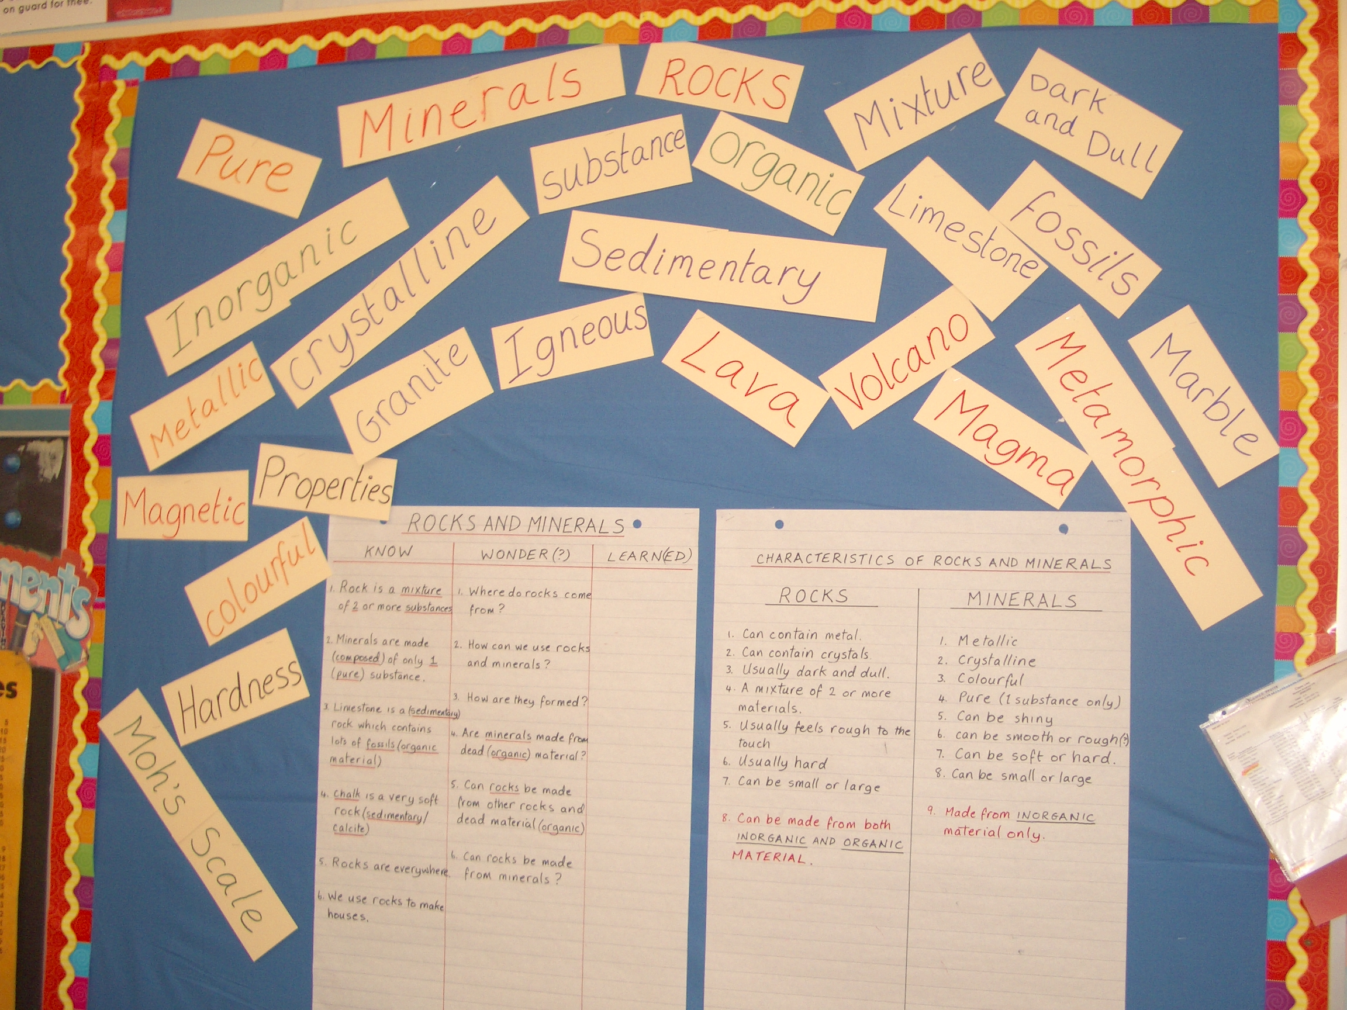
Fig. 1: Rocks and Minerals Word Wall (Grade 4)

when needed. If however, I felt through non-verbal gestures that a particular student was uncomfortable with an activity or having trouble understanding what I was saying, rather than
single them out, I would ask several students in a relaxed and jovial attitude “are you OK?...are you OK?...are you OK?” making sure that I also asked the one that I was really concerned about. This would allow them the chance to ask a question without feeling any undue pressure.

Guided Activity
The lesson activity requires group participation to visually deduce the identity of a rock sample with the aid of “scaffolding”. This teacher-led instructional strategy encompasses a range of important tools with the ultimate goal of helping the student make the transition from a dependent to an independent learner through sufficient internalization of a task or process (Education for all, 2005, p62-63). Scaffolding is provided in many forms, such as previously acquired knowledge, the activation of acquired knowledge through questioning and the provision and availability of previously created information within the unit, such as KWL charts and word walls. Its also provides where necessary the ability to adjust measured support to maintain a “zone of proximal development”, where the learning environment is one where the student feels comfortable taking risks. This activity is modeled by the teacher making details available through a “think aloud” strategies that cannot be readily be perceived by the student, for example, making predictions and inferences and evaluations (Education for all, 2005, p62-63).

Assessments
The range of assessments developed will accommodate students who possess a range of oral, visual and kinesthetic abilities. For this activity, an oral presentation rubric assessment and an observational table (see Appendix 1 and 2) were used where notes were posted for each individual during the activity. In addition, writing assessments of learning were also designed with accommodations in mind for all the children including the ELL students, which were completed during a one hours period with a break in between. Test language was simplified and accommodations were also provided for enrichment through the inclusion of high order thinking questions. The assessments (see attachments) depending on the student, included missing word tests, true or false quizzes (of varying difficulty) and creative writing assessments, where descriptive writing could either be full sentences or bullet points. Quiet environmental accommodations can also be made for the activity as and when required as it involves a small group.

Teacher self-assessment
ADD
References
- Fuchs, D., Fuchs, L. S., Mathes, P. G. & Simmons, D. C (1997). Peer-assisted learning strategies: Making classrooms more responsive to diversity. American Educational Research Journal, 34, 174-206.

- Fuchs, L. S., Fuchs, D., Yazdian, L., & Powell, S. R. (2002). Enhancing first-grade mathematical development with peer-assisted learning strategies. School Psychology Review, 31, 569-583.

- Ministry of Education document: “Education for All”: The Report of the Expert Panel on Literacy and Numeracy Instruction for Students With Special Education Needs, Kindergarten to Grade 6, 2005, p62-63.

- Ministry Document A: Supporting English Language Learners, A practical guide for Ontario educators, Grades 1 to 8, 2008, p53.

- Ministry Document B: Literacy for Learning: The report of the expert panel on literacy in grades 4 to 6 in Ontario, 2004, p57-58.

- Ministry Document C: Supporting English Language Learners, A practical guide for Ontario educators, Grades 1 to 8, 2008, p57-58; Law & Eckes, More than Just Surviving, 2000, p71-81. Winnipeg, Manitoba: Portage & Main Press.
Appendix 1:Observational Rubric Assessment
Group Activity: Lesson Plan on Identification and Classification of Rocks and Minerals

Name: _________________________ Date: ____________

 | Level 1 | Level 2 | Level 3 | Level 4
Demonstrates Understanding of material taught: Correctly identifies sample as rock or mineral | Not able to identify any samples correctly.  ___ | Able to identify some samples correctly.  ___ | Able to identify most samples correctly.  ___ | Able to identify all samples correctly.  ___
Communication:  Used vocabulary and terminology of the lesson and previously taught lessons relevant to current lesson. | Uses appropriate vocabulary and terminology with limited effectiveness.  ___ | Uses appropriate vocabulary and terminology with some effectiveness.  ___ | Uses appropriate vocabulary/ and terminology with considerable effectiveness.  ___ | Uses appropriate vocabulary and terminology with a high-degree of effectiveness.  ___
Communication: clarity | Student’s voice is not clear, and speaks too quietly.  ___ | Student's voice is low and audience members have difficulty hearing student speak.  ___ | Student's voice is clear and most audience members can hear student.  ___ | Student uses a clear voice and all audience members can hear student.  ___
Thinking and Investigation:  Used critical and creative thinking processes, skills and strategies during group activity. | Uses critical and creative thinking processes, skills and strategies with limited effectiveness.  ___ | Uses critical and creative thinking processes, skills and strategies with some effectiveness.  ___ | Uses critical and creative thinking processes, skills and strategies with considerable effectiveness.  ___ | Uses critical and creative thinking processes, skills and strategies with a high-degree of effectiveness.  ___
Appendix 2: Teacher Observation Notes
(For anecdotes, informal observation notes)
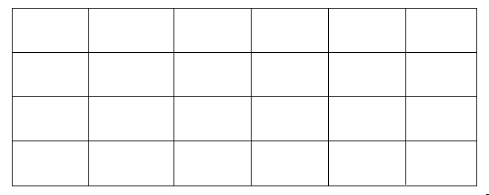
Having a ready supply of observation notes is a good way to quickly record key points while doing observational assessments during a lesson.

Instructions:

- Refer to sample above to create a grid on 11.5” x 17” (legal) size paper to handle the class size:
  - 4 x 6 if 24 students in class
  - 5 x 6 if 30 students in class
  - 4 x 7 if 28 students in class

- Arrange student names alphabetically in the corner of each rectangle. Type their names on the master grid you create, to make form easy to use as a template for subsequent observation sessions.

- For each student, record date and other observational details pertinent to the lesson.

- At the end of the observation period or week, cut up the grid and paste the notes you have recorded into individual student folders. The sheets in individual folders can be colour-coded for each reporting period for easy access.

