Native Studies Education
Part I - Native History
Indian Act: first passed in 1876 by Canada. It was, and is, a separate set of laws for Indigenous peoples covering virtually all aspects of daily life (apartheid). It was through the Indian Act that reservations, band councils, and status were imposed.
Reserve system:
- reserves stripped natives of their land, culture, language and identity (cultural genocide)
- schools built on the reserves with the goal of educating natives in the European way of
life.
- competition between Catholic and Anglican missionaries imposing European
worship and missionaries often ran the schools.
- goal of assimilation of native children meant that traditional ways of life would cease
and would no longer be passed on to future generations.

Residential school era:
- abuse, loss of language, culture and identity (late 1890s-1970s)
- federal day schools (following residential school era) were established so that native
children could attend school on their reserve. Problem – no native education content
(language, literature, culture).
1950s - government push to integrate native students into provincial schools with the
goal of integrating Indians into Canadian society.

1969 - Canada revealed a plan for abolishing the Indian Act & phasing out reserves, known as
the 'White Paper''. This act ignited protests by Natives across the country as it meant
dispossession of their last remaining land base: the reserves.
1970s - Federal government transferring reserve schools to local control (end of
residential school era). Bands are required to sign funding agreements; they must
follow provincial education standards and guidelines = lack of native content in
education.
1980s - almost half of native students attending the provincial school system, no Aboriginal
content in education and very low student success rates at high school and
post-secondary levels.

Current Affairs
1. In the mid-1990s the Ministry of Education began to examine the lack of native content in
education.
2. The Native Studies MOE curriculum document is out of date (1999).
3. Native Studies courses are only offered when there is enough enrolment (numbers).
4. Native Studies courses are offered where Aboriginals live and go to school.
5. There is no mandatory high school Native History course.
6. Some Post-secondary institutions have done a good job of offering native courses –
Laurentian University and Trent University - degree programs in Native studies.
7. Laurentian University Concurrent B. Ed program (2003) integrates native education
throughout the program, the history of First Nations education is mandatory.
8 . Collaborative projects: Curriculum partnership between Kenjgewin Teg Educational
Institute, the Rainbow District School Board and the Ojibway Cultural Foundation.
http://www.culture.gov.on.ca/video/premiers_award_08_video_ojibwe.htm
9. Use of Geographic Information Systems for land claim settlement and for developing healthy
economies on reserves.
http://www.nrcan-rncan.gc.ca/com/audpub/aboaut-eng.php
Other:
1. Apology from Prime Minister Harper, June 11, 2008
http://www.cbc.ca/canada/story/2008/06/11/aboriginal-apology.html
2. Residential lawsuit settlement Saskatchewan - REGINA 2006 -- largest class-action
settlement in Canadian history -- brokered on behalf of thousands of former aboriginal
residential school students -- has been approved by the courts (Tony Merchant, Regina
lawyer whose firm represents more than 10,000 claimants).
Part II
Report: Ontario First Nation, Métis and Inuit Education Policy Framework (2007): Delivering Quality Education to Aboriginal Students in Ontario’s Provincially Funded Schools.
Issues affecting Aboriginal achievement:
1. Lack of awareness – teachers are not aware of the particular learning styles of Aboriginal
students.
2. Lack of understanding among schools and school boards about Aboriginal culture, history and
perspectives.
3. Lack of available native curriculum documents, books and materials produced by Native
people.
4. Intergenerational mistrust of the education system due to the residential school system.
5. Poor sense of identity due to marginalization in the school system and society.
6. Alcohol, drug and physical abuse on reserves.
7. Lack of educated Native role models.
8. Lack of qualified native teachers due to low post-secondary graduation rates.
9. Neglect or abuse of ‘status’.
Framework Principles:
1. Excellence and Accountability
2. Equity and Respect for Diversity
3. Inclusiveness, Cooperation and Shared Responsibility
4. Respect for Constitutional and Treaty Rights

Historical Context:

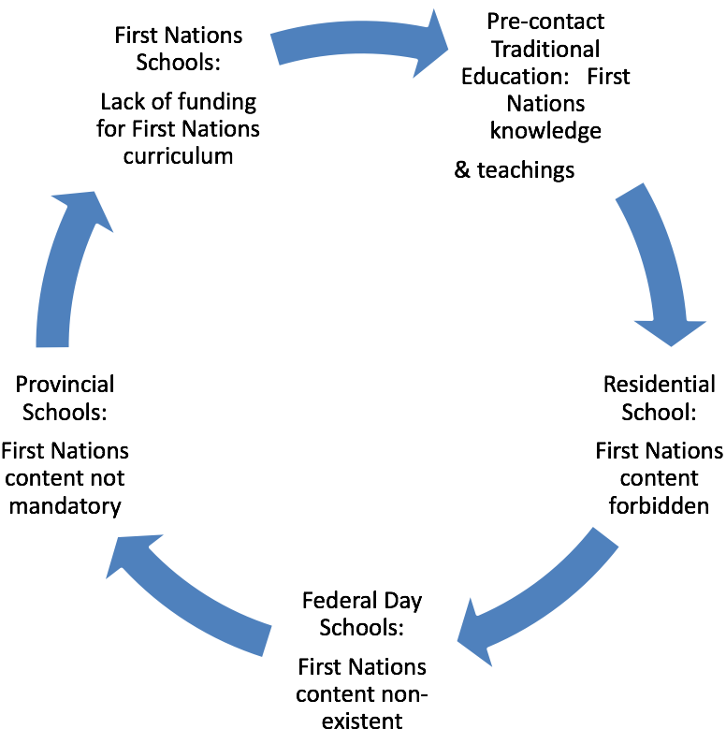

Dr. Emily J. Faries (2004). Research Paper on Aboriginal Curriculum in Ontario,
pg 4.

First Nations needs:

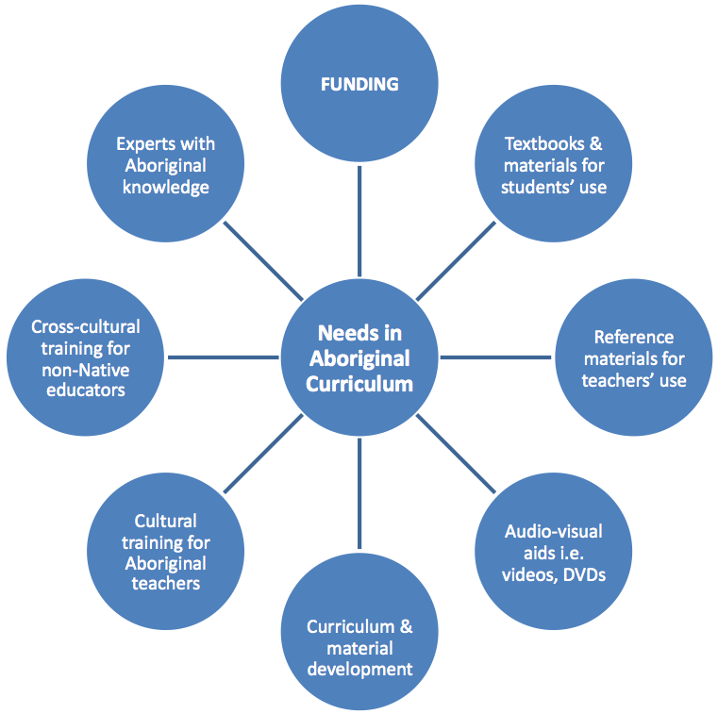

Dr. Emily J. Faries (2004). Research Paper on Aboriginal Curriculum in Ontario,
pg 9.

Bibliography
Aboriginal Education Office and Ministry of Education Office (2007).
Ontario First Nation, Métis and Inuit Education Policy Framework.
Retrieved September 25, 2008, from http://www.edu.gov.on.ca/eng/aboriginal/fnmiFramework.pdf
Aboriginal Healing Foundation (1999). Where are the children? Healing the legacy of the
residential schools. Retrieved October 24, 2008, from http://www.wherearethechildren.ca/en/home.html
Canadian Broadcasting Corporation (2008). Education. Retrieved October 24, 2008, from
http://archives.cbc.ca/society/education
Eigenbrod, R., Fiddler, J., & Kakegamic, G., Aboriginal literatures in Canada: A teacher's resource guide. Retrieved September 25, 2008, from
http://www.curriculum.org/tcf/teachers/projects/aboriginal.shtml

Faries, Dr. E. J. (2004). Research paper on Aboriginal curriculum in Ontario.

Hesch, R. (1999). Culturally relevant teacher education: A Canadian inner-city case. Canadian Journal of Education, 24(4), 369-382.
Hudak, H., & Tait, L. (2007). Aboriginal peoples: Early Canada.
Calagary, Alberta, Canada: Wiegl Educational Publishers Limited.
Ministry of Education (1999). The Ontario curriculum grades 9 and 10 Native studies.
Retrieved September 25, 2008, from
http://www.edu.gov.on.ca/eng/curriculum/secondary/nativestudies910curr.pdf

Natural Resources Canada (2008). Aboriginal Resources. Retrieved October 24, 2008, from
http://www.nrcan-rncan.gc.ca/com/audpub/aboaut-eng.php
Rainbow District School Board (2006). First Nation, Métis and Inuit Education in Rainbow schools. Retrieved September 25, 2008, from http://www.rainbowschools.ca/programs/FirstNations.php
Silvey, D., & Mantha, J. (2005). The kids book of Aboriginal peoples in Canada.
Toronto, Ontario, Canada: Kids Can Press Ltd.
Statistics Canada (2006). Educational portrait of Canada, 2006 census: Aboriginal population. Retrieved Oct 6, 2008, from http://www.statcan.gc.ca

Surtees, R. J. (1986). Treaty research report Manitoulin Island treaties.
Retrieved September 25, 2008, from
http://www.ainc-inac.gc.ca/al/hts/tgu/pubs/Mtou/tremtou-eng.asp

